**JUEL TOURS**

**3 days Mombasa tour package**

**Places to visit**

1. **Haller park**

* Experience variety of plants and animals in their natural habitat. Examples are –

Giraffes, elands, Oryx, tortoise, Hippo and crocodiles.

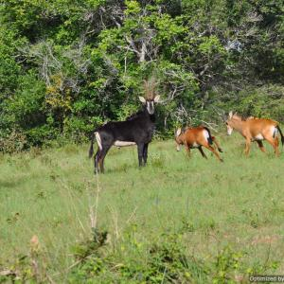 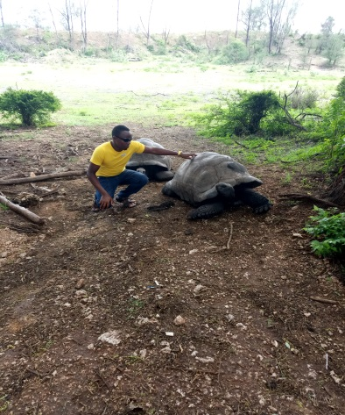

1. **Mamba Village**

Get a first hand encounter with crocodiles at mamba village. This is the largest crocodile firm in Africa. You also have a chance to see different types of snakes. You can also enjoy a horse ride and finally have a taste of crocodile meat which is so delicious.

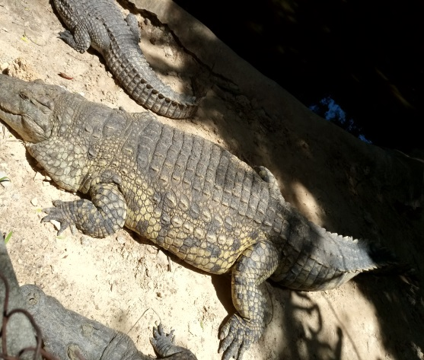 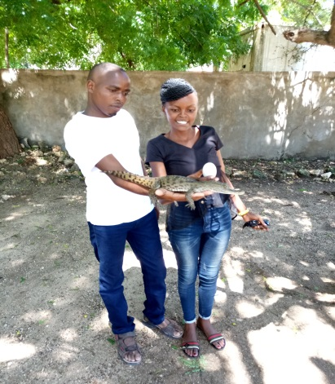

1. **Mombasa Marine Park**.

Experience the white sandy beaches and coconut palms while enjoying the cool breeze along the Kenyan coast beaches in Mombasa Marine Park. You also get a chance to experience the breath taking diving sites and snorkeling. You can also watch crabs, star fish and coral turtles at this destination.

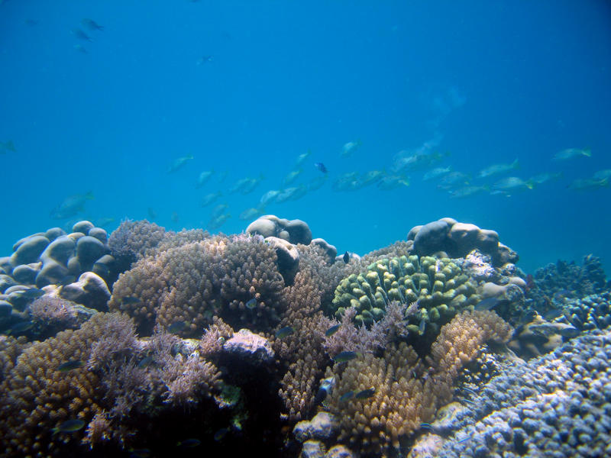

1. Enjoy the coastal culture by socializing with different groups of people at **Jomo Kenyatta public beach,pilate beach, Nyali beach and Shanzu beach**

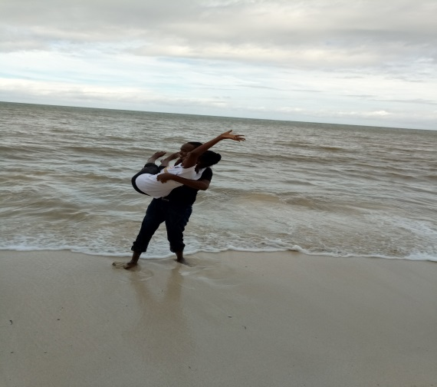

1. Make a visit to the **wild waters** in Mombasa. It has kids’ fun facilities and a nice restaurant with Swahili dishes. This is a very nice place to visit.

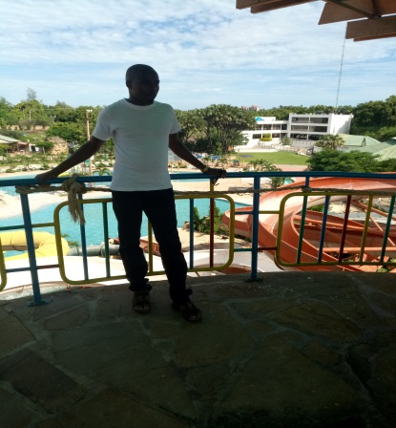

1. As you conclude, do not leave without a visit to **the fort Jesus**. A place of historical monuments and take your time to understand the Kenya history.

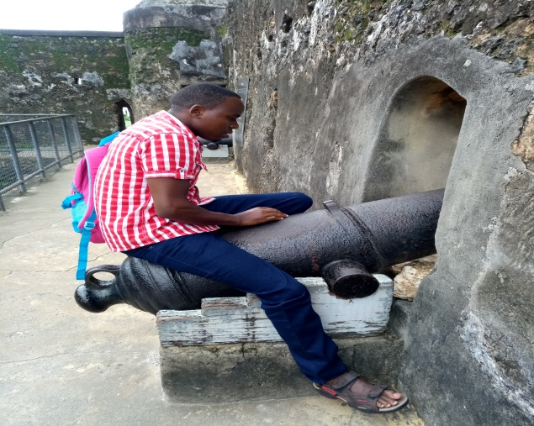

1. Other places you can think of visiting if your time allows include at an extra cost.

* Nguuni nature sanctuary
* Mwaluganje elephant sanctuary
* Arabuko sokoke national park
* Simba hills